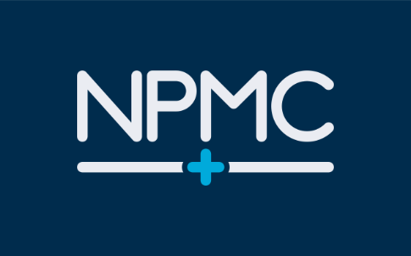
Produced by the NPMC PPG on behalf of NPMC
NPMC newsletter No.3 Summer 2023
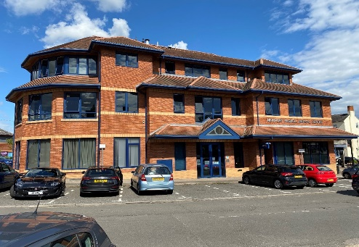
NPMC NPMC@Willen
Welcome to our summer newsletter, which Dr Chandola and partners hope will be of interest and help to all our 22,300 patients in Newport Pagnell and Willen. A copy of this, and the previous newsletters, can also be downloaded from the NPMC website.
Are you an Asthma Sufferer?
Summer pollens and summer colds can contribute to problems for asthma sufferers. Patients should check that inhalers remain within date and order new ones if necessary.
Remember – Out of date inhalers must be returned to a pharmacy for disposal and must not be placed in domestic waste.
Size of text
As requested by a patient, the text size has been increased to 14 point, so that it can be more easily read by those patients with limited vision. Please let us know if this helps.

Hay Fever?
Make sure you have enough anti-histamines at home. You may need to take one if you are affected by tree or plant pollen after a walk.
Booking-in
On arrival at both NPMC and NPMC@Willen, please book in using the automatic system just inside the building doors. There is also a second machine on the first floor at NPMC, in waiting room 2. Doing this will save patients queuing to speak to the receptionist and will inform the person you are due to see that you have arrived.

Booked summer holidays in the UK or abroad - or planning to do so?
- Take enough of any prescribed items with you, allowing for the possibility of a delay of several days before being able to get back home if you are travelling abroad. Check with your travel agent to ensure that no problem will arise in taking prescribed items with you, in case of any local restrictions.
- Order any required prescription in good time before your holiday.
- Take written details of your prescribed medicines with you, to show a doctor or hospital in the event of any health problems while on holiday. Check if any specific inoculations or tablets are required for your holiday destination, if distant, and ensure that you arrange to have the inoculation in good time.
- Take a small first aid kit with you, in case of minor injuries, cuts or bruises. Include paracetamol or ibuprofen (unless prohibited in your destination) and a pack of antihistamine tablets, which may help with a minor allergy to unfamiliar plants or foods.
- If going to Europe, apply for an E-HIC certificate for each traveller through the NHS website. This may help with the cost of medical treatment in the EU, but is not a replacement for appropriate travel insurance.
- Remember that payment for medical services may have to be made in some countries and ensure that you keep receipts, as part of a travel insurance claim.
- Don’t forget high-factor sun cream and a sun-hat or cap!

Symptom Tracker Form
It can sometimes be difficult to remember the details of a medical problem when it comes to seeing or speaking to a GP or when completing AccuRx. A symptom tracker form can be found through the Templates tab on the NPMC website and downloaded so you can record details.
It may also be a useful document to complete ahead of a hospital appointment, as a way to record anything important which you will need to mention when you see your consultant.

Autumn Flu Clinics
NPMC has already ordered doses of this year’s flu vaccine. Details of the flu clinics will be placed on the NPMC website in due course and hopefully included in our next newsletter.
NPMC is already committed to the purchase, so eligible patients are requested to book their appointments with NPMC when the invites go out to them.
Face to Face Appointments
NPMC and NPMC@Willen continue to offer face to face appointments. Initial contact with a patient may be by phone. Evening and weekend appointments are available through our linked service (see the last page of this newsletter). Initial advice may also be obtained from a pharmacist.
For urgent or continuing medical problems, especially when the surgery is closed, please telephone NHS111 and take their advice.
In an emergency, please call for an ambulance or attend the Emergency Department at the hospital.

May Appointment Statistics

In May 2023, NPMC GPs carried out 683 face to face appointments and 2839 telephone appointments. Additionally, the nurse practitioners saw 2933 patients and advised 386 others by telephone.
In the same period, NPMC@ Willen GPs carried out 138 face to face appointments and 460 telephone appointments and nurse practitioners and other clinicians patients saw 732 and advised 57 others by telephone.
Please keep your Appointments
If an appointment has been made for you, whether at the surgery or by phone, please keep it.
If you do not attend or cannot be contacted by phone, you will not automatically be given a replacement date.
This may cause quite a delay, which may not be in your interest.
In May 2023, there were 234 unattended appointments at NPMC and 51 at NPMC@Willen

Are your details up to date?
Please notify the surgery if you have recently changed address or contact telephone number. It is important that the surgery has the correct up-to-date details. If you ask for an appointment, but your correct contact information is not up to date, you can’t be contacted as needed.

Do you have more than one medical condition or take several prescribed medications?
You should be able to give full and accurate details of your medical conditions or past history and of any current prescribed medication. It can be difficult to remember all the information, especially if you are feeling unwell. In particular, details of current medication may be vital to anyone prescribing new medication, to make sure that this will not clash with any other prescribed items.

Consider taking some or all of the following steps:
- Keep a written note of current prescribed medication in your wallet or purse.
- Also include a note of any allergies or important previous medical problems.
- Add the details to the notes section on your mobile phone.
- Wear an SOS talisman, into which you can add medical details.
- Join an organisation such as Medic Alert, which can keep a record of your medical conditions and prescribed medication and from which you can purchase an engraved bracelet or necklace with important information.

The new MK Recycling Scheme
All properties locally should have received a leaflet about the new waste and recycling scheme, which is due to start in Newport Pagnell in early September.
When the scheme starts, the existing weekly arrangements, using self-supplied black bags for non-recyclable items and see-through bags and blue plastic boxes provided by MK Council, will end.
Over the next 3 months, most homes will be provided with 3 new wheelie bins, with different-coloured lids. Non-recyclable items are to be placed in the bin with the black lid. This, together with the existing green bins for garden waste, will still be collected weekly.
Glass will go into the blue-lidded bin, together with metal and recyclable plastic. Paper and cardboard will be placed in the red-lidded bin. Only one of these wheelie bins will be collected each week, starting with the blue-lidded bin in the week starting 4 September and the red-lidded one in the week starting 11 September.
Some properties will not be suitable for the new total of 4 wheelie bins. Those will be supplied with red sacks for paper and cardboard and blue sacks for glass, metal, tins and plastic. Households will continue to supply their own black bags for other non-recyclable items. Collection of black bags will still be weekly, but the blue and red bags will be collected fortnightly.
For those in flats, there should be large communal bins for recyclable items.
It is still possible to take recyclable items to one of the Council’s waste disposal sites, but don’t forget to book a visit.
Are you a Gardener and a Recycler?
If you grow flowers or vegetables from seed, consider using recycled items when they are ready for transplanting.
Plastic cream and yoghurt pots (particularly the large ones) are ideal. Many are more colourful than the standard small brown or black pots from garden centres or DIY stores and will look good on your windowsill or a greenhouse shelf.
Ice cream tubs are also useful, especially for starting off a number of seedlings before they are ready to be potted on into individual containers.
Stamps with just the Queen’s head
If you still have any ‘definitive’ stamps without an attached barcode, these can only be used up to 31 July, but can be exchanged for the new barcoded stamps after that date.
This only applies to 1st and 2nd class stamps with the late Queen’s head and the indication of 1st or 2nd class, including stamps marked ‘Large’. These are smaller than the stamps with an attached barcode, which have been issued over the last year.
You can still use any old ‘pictorial’ or ‘special edition’ stamps which include a photo or design on them as well as the monarch’s head and a printed value – but you may have to purchase other stamps to make up the value to the current level.
New stamps now feature an image of King Charles III.
Have you received a letter or text message asking you to arrange an appointment for a health check, a scan, a blood test or to discuss a recent test?
Have you received a letter or text message asking you to arrange an appointment for a health check, a blood test or to discuss a recent test?
Information of this sort will normally come from the surgery. In some cases, the contact may be part of a national campaign, such as provision of a kit to check for possible early signs of bowel cancer, or for a repeat mammogram or another regular test. Some health checks are made when patients reach a particular age, or at a set time since the last one.
It is in your own interest that you do make the appointment or carry out the test when asked to do so, and keep it. While most of these are usually routine, they can occasionally show up a problem which might not otherwise show itself for some time. Catching and treating a problem early can sometimes mean that it can be satisfactorily be resolved in your own interest.

Prostate Cancer Screening
Milton Keynes Prostate Cancer Support will be organising a PSA testing day in November, probably at Windmill Hill Golf Club. Details will be placed on the group’s website https://www.prostatemk.org/. Attendees will be asked to make a payment for the PSA test.
Prescriptions and Medicines
Are your prescriptions up to date? If you have a medicine cupboard, check the expiry dates of both prescribed and over–the-counter medication and replace any which have passed their expiry date.
Any unused prescription medicines should be disposed of safely, by depositing them with your local pharmacist. They should not be placed in domestic waste.
Don’t forget to check the contents of any specific first aid kits, whether kept at home or in a car, and replace any out of date items.

HOSPITAL NEWS
Recently published information indicates that waiting lists at Milton Keynes University Hospital for all kinds of appointments have reduced by more than the national average. There may still be delays between a referral by a GP and a first appointment with a consultant or a scan, but it should be quicker than in other parts of the country. (Source: Milton Keynes Citizen 25 May 2023)
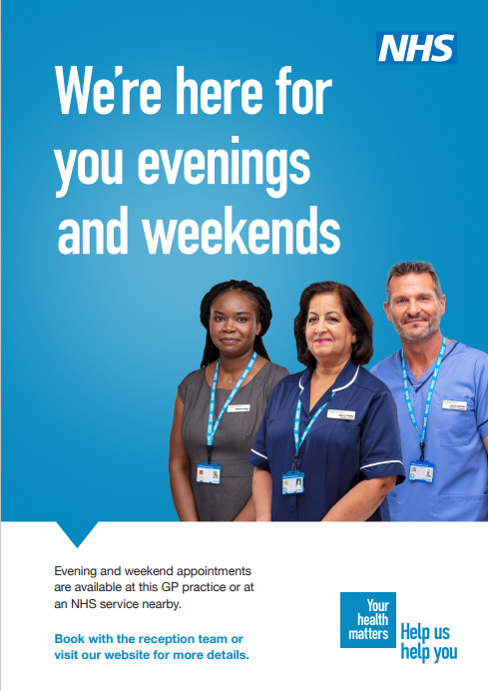

The Patient Participation Group (PPG)
The PPG is a group of up to 12 patients who give up their time and act as a means of advising and assisting NPMC, through monthly meetings and otherwise as needed, in order to help bring about improvements in the service provided to patients where possible. Any patient interested in joining the PPG should apply to the NPMC Practice Manager.

Future Newsletters
Our newsletters are published quarterly. Please let us know what you think about this newsletter and if there is anything which you would like to see in future issues. You can do this by email on blmkicb.npmcppg@nhs.net, by completing a Comments form at the reception area of either surgery, on the first floor in waiting room 2 at NPMC, or by accessing it through the NPMC website.

