My Care Record
GP PRACTICE DIGITAL COMMUNICATION PACK

Communication is a fundamental part of the My Care Record approach. As part of an extensive campaign, the My Care Record team will be working with all partner organisations, external bodies such as Healthwatch and engaging with local press through the CCG and other partners. GP practices play a key role in this communication activity.

This pack contains resources to support your practice to communicate My Care Record, firstly to all colleagues, followed by patients. Wherever possible, resources are provided as links to items held on the My Care Record website. This is to ensure that you can always access the most up-to-date version of materials. Other materials that are specific to BLMK are included as appendices to this document. Please do not download items to house locally.

Thank you in advance for all your help. Please contact vicki.anderson@micoconnected.co.uk with any questions about the communication materials or ken.thompson2@nhs.net about the wider approach and Information Sharing Agreement. Please also let us know if any other materials would be helpful to you.

STAGE ONE - Communication with colleagues
Please ensure your colleagues are aware of My Care Record, understand its benefits, how it works and where to find answers to any questions they have or may receive. This includes all health professionals and administrators.

- An introductory email was included when this pack was sent to you. Please ensure this has been sent to all staff at the practice.

- The following resources are also available to support you, for example for use in team meetings:

- My Care Record Introduction for Health and Care Professionals
- FAQs for Health and Care Professionals
- Animation (the animation is also housed on YouTube: https://www.youtube.com/watch?v=8czDG6pCOzE

STAGE TWO – Communication with the public (fair processing)
A key requirement to make the My Care Record approach live is ensuring that members of the public know how and why we will use their information. This communication is called fair processing. We are asking all organisations to help communicate through their public-facing channels for a minimum of twelve weeks.

Please ensure:
- There is information on your public facing website
Text and images to use are provided in this document:
- Partner organisation website content
- Website banner

- Information is displayed in public sites
- Digital screen displays are available in three formats: JPEG format / PNG format / PDF format Please use these within waiting areas. If content is usually uploaded by the CCG, this will be organised for you.
- Posters and printed copies of some of the key documents will be delivered directly to you at the practice. Please make these available in public and staff areas when they arrive. We have kept handouts to a minimum due to current infection control measures, but if you would like more printed resources, please let us know.

The following items are also available to support you:

- Frequently Asked Questions for the public
- Easy Read Information
- Translated information (coming soon) - Content is being translated into several of the most common languages across BLMK. We will let you know when they are available to download from the My Care Record website.

Wherever possible, please also help us to reach members of the public through other communication channels:

Public-facing newsletters/emails
Please use the content for newsletters or email updates to patient groups provided below in APPENDIX ONE.

Patient Participation Groups
Please ensure your Patient Participation Group is informed about My Care Record and let us know if they would like a member of the team to present to them.

Social media
Public-Facing social media posts are provided for Facebook and Twitter as appropriate, please find below in APPENDIX TWO.

Prescription messages
If you are able to add a printed message to scripts, please use the following text:

------------------------

My Care Record enables health and care professionals to access information about you to improve your care. Please visit www.mycarerecord.org.uk to find out more.

------------------------

Text messages

If you would like to text patients, a message is provided below. While it would be a valued means of communication, it is not a requirement as we understand there are time and cost considerations. The below message is one text (160 characters), depending on the length of the practice name inserted.

--------------------------

MESSAGE FROM [INSERT PRACTICE NAME XXXXXXXX] We are part of a new approach that is improving care by joining up information. Learn more: www.mycarerecord.org.uk

--------------------------

APPENDIX ONE – PUBLIC-FACING NEWSLETTER CONTENT – GP PRACTICES

When using content for e-newsletters, please consider including the My Care Record animation:
Animation also available on YouTube: https://www.youtube.com/watch?v=8czDG6pCOzE

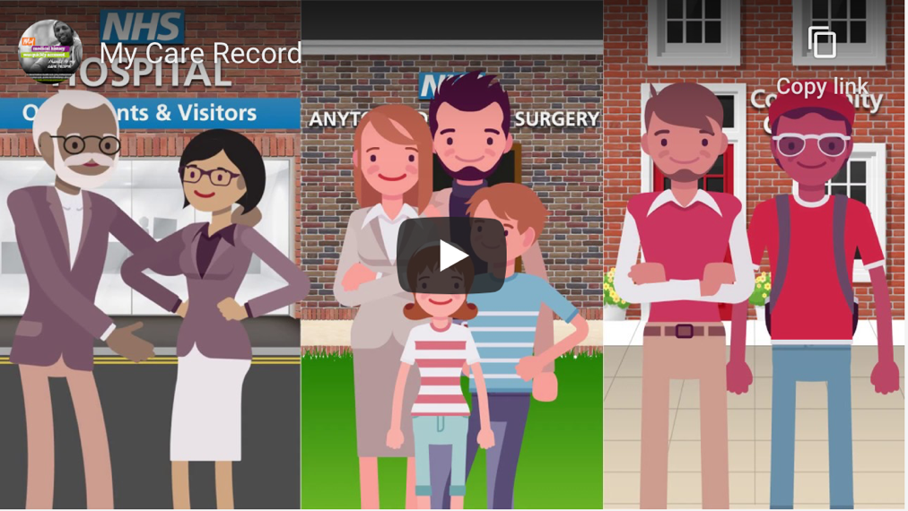

Use the links to download the assets used below:
My Care Record logo
My Care Record benefit icons

------------------------------------------

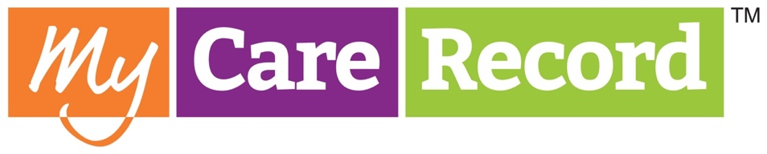

My Care Record – joining up information to deliver better care across Bedfordshire, Luton & Milton Keynes

We are joining health and care organisations across BLMK to implement a new approach called My Care Record.

My Care Record is an approach to improving care by joining up health and care information. Wherever possible, health and care professionals will be able to access your records from other services when it is needed for your care. For example, a hospital-based doctor or a community nurse could view information from your GP record.
Dr. Paul Singer, Luton GP and Chief Clinical Information Officer for BLMK Integrated Care System explains:

“We know that when information is made available in a more joined-up way, we can provide faster, more effective care. Over time My Care Record will mean that individuals don’t need to keep repeating their stories. The right professional at the right time will have access to the information they need such as test results and medication to make decisions about treatment and care.

"The Coronavirus pandemic has highlighted the need to work together across services to deliver care, often from different locations. My Care Record is a key tool for making this happen.”

Several different secure computer systems are used across the region. In some areas these are already in place, in other areas more work is underway to invest in the technology needed. The approach also provides an agreement between all the health and care organisations involved. In line with GDPR, this means they commit to sharing information in a secure way to help improve care.

Health and care professionals may access records from different services to improve the overall care an individual receives. Certain information – that doesn’t identify the individual – will also be used to help improve services and plan for the future. For example, it will help us plan for the number of doctors, nurses, and care workers needed in the future.

Individuals who do not wish for their information to be shared can speak to the person delivering care at each organisation such as their GP, specialist, or social worker.

Please visit www.mycarerecord.org.uk for more information including a list of the organisations involved.

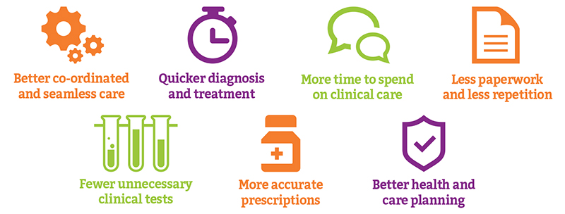

APPENDIX TWO – PUBLIC-FACING SOCIAL MEDIA GP PRACTICES

Images are available to download from the social media section of www.mycarerecord.org.uk/resources

TWITTER 1:

My Care Record will help health and care professionals across Bedford, Luton and Milton Keynes to access the information they need for your care. Learn more about our new approach https://youtu.be/8czDG6pCOzE

TWITTER 2: Twitter image - man

My Care Record will help health and care professionals to access information to improve your care – even if they work for different services or in different locations. Learn more about the benefits: www.mycarerecord.org.uk.

FACEBOOK 1: (image generated from link)

https://youtu.be/8czDG6pCOzE This animation explains our new approach to improving care by joining up information. My Care Record will enable health and care professionals in our region to access the information they need to care for you.

Over time it will mean that you will not have to repeat your story. The right professional at the right time will have access to information such as test results and medication, to help make the best decisions about your care.

FACEBOOK 2: Facebook image - boy

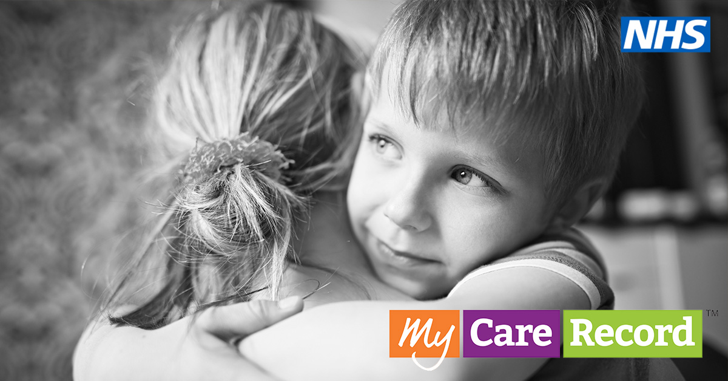

We are joining My Care Record, a new approach to improving care by joining up health and care information.
Wherever possible, My Care Record will enable the health and care professionals helping you to access the information they need - even if they work for different organisations or in a different location.
This will bring significant benefits including faster diagnosis and treatment, fewer unnecessary tests and more time to spend on clinical care.

Find out more at www.mycarerecord.org.uk.

