NPMC Newsletter No.1
January 2023
Produced by NPMC PPG on behalf of NPMC

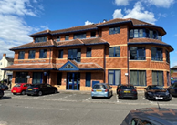

NPMC & NPMC @ Willen

NPMC and the PPG wish all our patients a “Happy New Year”.
Welcome to our first newsletter, which Dr Chandola and Partners hope will be of interest and help to all our 22,300 patients in Newport Pagnell and Willen.

The plan is to produce quarterly newsletters.

A copy can be downloaded from the NPMC website
The Patient Participation Group (PPG)
The PPG is a group of up to 12 patients who give up their time and act as a means of advising and assisting NPMC, through monthly meetings and otherwise as needed, to help bring about improvements in the service provided to patients where possible. Any patient interested in joining the PPG should apply blmkicb.npmcppg@nhs.net

Future Newsletters
We are planning to prepare newsletters quarterly. Please let us know what you think about this newsletter and if there is anything which you would like to see in future issues. You can do this by email to blmkicb.npmcmail@nhs.net or by completing a Comments Form from the reception areas of either surgery or accessing it through the NPMC website.

Booking-In
On arrival at both NPMC and NPMC@Willen, please book in using the automatic system just inside the building doors where possible, this will save patients queuing to speak to the receptionist and will ensure that the person you are due to see is aware at the earliest stage that you have arrived. Even though it is no longer a national requirement, it is recommended that anyone attending either NPMC or NPMC@Willen should wear a facemask and use the hand gel provided.

Telephone Appointments
If a telephone appointment has been arranged, it is important that you are properly prepared in the same way as if you were to attend a face to face appointment. This may mean putting some notes together ahead of the appointment (or perhaps you might complete the NPMC online Symptom Tracker Form if appropriate). A telephone appointment is usually intended to clarify anything which is not clear from details entered online on AccuRx, or where it is not thought that a face to face appointment at the surgery is necessary. The clinician may suggest that a visit to the surgery is required, for an appointment with a doctor or other clinician.

Face to Face Appointments

NPMC and NPMC@Willen continue to offer face to face appointments. In many instances, initial contact with a patient will be by telephone. Evening and weekend appointments are available through our linked service, for which please see details on the last page of this newsletter. Initial advice may also be obtained from your local pharmacist, but for urgent or continuing medical problems, especially when the surgery is closed, please telephone 111 and take their advice.

New Symptom Tracker Form

Often, patients may experience problems for some time before contacting the surgery, or between initial and follow-up appointments. It can sometimes be difficult to remember the details of any such issues when it comes to seeing or speaking to a GP or when completing AccuRx. A symptom tracker form has been prepared, as suggested by a member of the PPG, and this can be accessed through the Templates tab on our website in the ‘Online forms tab’ and downloaded so it can be filled in as needed. It may also be a useful document to complete if you have a hospital appointment and need a way to record anything important which you may need to mention when you see your consultant.

Know Your Body

Everyone should know what feels ‘normal’ for them – this varies from person to person. If you experience a new health problem, especially one which gets worse quickly or persists for a week or more, it may be important to obtain medical advice.

Prescriptions and Medicines
Are your prescriptions up to date? If you have a medicine cupboard, check the expiry dates and replace any which have passed their expiry date.

KEEPING WARM THIS WINTER
Tips from the PPG

Cream of Potato Soup
(Winter Warmer)
This recipe makes enough for 4 – 6 people, so would be ideal to provide enough to put some into the fridge or freezer for another day.
You will need:
I medium brown onion; 2 oz, (56 g) of butter; 2lbs 4 oz. (1 kg) of floury potatoes, peeled and diced; 2 egg yolks; 3 pints (1.75 litres) vegetable or chicken stock; 1 bay leaf and half a tablespoon (3 g) soft thyme leaves; 4 tablespoons (56 g) finely chopped parsley and 2 tablespoons (12 g) snipped chives; seasoning to taste; a small amount of cream.
Method:
Cook the onion, thyme and bay leaf with the butter over a gentle heat for about 10 minutes, or until the onion has softened.
Add the potatoes and cook for about 5 minutes, or until the potatoes have started to stick to the bottom of the pan. Add the stock, then bring to the boil and simmer until the potatoes are tender.
Liquidise the soup (you will need to do this in batches) and then pass the liquid back into the pan through a sieve. Add the parsley and chives while heating the mixture over a low heat.
Whisk together the egg yolks with some cream and fold into the soup. Cook over a low heat for 2 minutes (make sure that it does not boil), adding seasoning to taste and then serve.
Tip:
As always, the recipe can be varied to suit personal tastes or if you do not have all the ingredients. Dried thyme or parsley could be added instead of fresh items. Add paprika for a slightly hotter taste. Adding leeks or other vegetables will alter the taste and/or the texture of the soup.
Tips for Saving Fuel/Electricity

Only boil a kettle for the actual amount needed by filling your usual cup or mug with cold water and pouring that into an empty kettle (double quantity for two drinks). Make sure that you add enough water to any marked minimum amount on the kettle, otherwise the heating element may burn out.
Consider using a microwave instead of a kettle to boil water for hot drinks. If you have a thermos flask or insulated cup, boil enough water to make something to drink immediately and to make a drink for later.
Keep your main living area warm so as to feel comfortable. A minimum temperature of 20 C (68 degrees Fahrenheit) is usually recommended, but this will vary according to personal circumstances if there are very young children or elderly persons in the home, if anyone is unwell or has been advised to maintain a warm home. In addition, putting on an extra layer of clothing, such as a T-shirt or jumper, should help.
Turn off radiators in rooms which are not used regularly. This will include spare bedrooms, although these will need to be aired for a short time before any guests come. Do radiators in a hallway or bathroom need to be on? Kitchens should warm up when a meal is being cooked so may not need a radiator on.
Make sure that your home is as well-insulated as possible, including closing doors to keep heat in or to avoid heat passing into unused rooms. There are government schemes to help with insulation issues for some properties.
Make sure that you have applied for, or have received, any available help towards winter fuel bills from the government or through the local authority.
Stock up on tinned and frozen food, to avoid having to go out in cold, icy or wet weather.
If you have fridge or freezer space, consider making double quantities of meals so that the second one will only need to be warmed through (after defrosting if it has been frozen) when needed. Make best use of your oven by making 2 or more different meals, including one for later, or doing some baking at the same time as cooking a meal.
If the weather forecast is reasonable, use your washing machine overnight night and hang out washing in the morning, so that morning sun and any breeze will at least start the drying process. This usually leaves clothes smelling better than using a tumble dryer. Avoid placing wet clothes on radiators, which may lead to condensation.

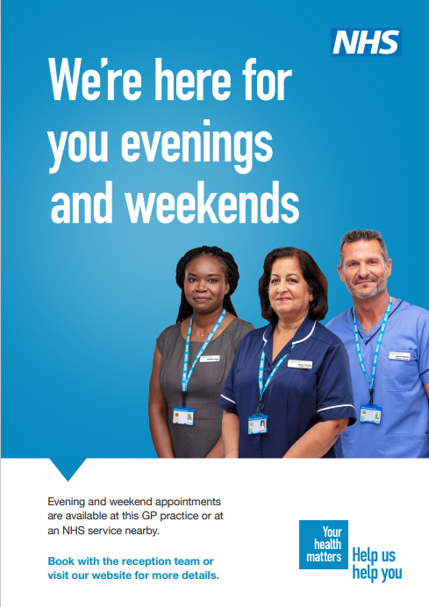
Evening and Weekend Appointments

Local GP Practices are working together to offer patients evening and weekend appointments.

This means that you will be able to see a GP, nurse or other healthcare professional, at our Willen Practice, or another participating practice, at a time which is most convenient, for such as:

- Early morning blood test appointments from 7 am

- Weekend appointments from 8.00 am until 6.00 pm (consisting of both face to face and telephone consultations)

- Evening appointments from 6.00 pm until 9.00 pm

HOSPITAL NEWS
As at the beginning of October 2022, approval has been given to the construction of a radiotherapy unit at Milton Keynes University Hospital.

It is expected that the new unit would be positioned between the Cancer Centre and the multi-storey staff carpark. It is hoped that there will be a direct corridor between the new unit and the Cancer Centre. Construction will soon start, with a projected completion date in Spring 2024.

This will save patients having to travel to Oxford for radiotherapy, with all the practical problems this can cause.

This is a project which has long been awaited and it is hoped that this will prove to be of great help to patients in this area.

